IKEA Materialized Bed

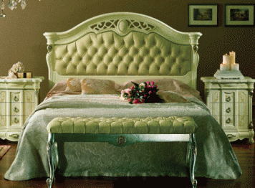

|  |
| --- |
| **DESCRIPTION** |
| IKEA introduces stylish bed with a white slummed design. The bed gives a royal look which forced us to create a perfect environment for the user to be completely satisfied. Sure to create the perfect look in any house. The rich wood of the bed pairs perfectly with many different styles of decor. Perfect for your bedrooms or just an extra help in your house, your guests will love this comfortable bed. |

|  |  |  |
| --- | --- | --- |
| **Price** | **1960$** | |
| **Dimensions** | **H** x **W** x **L** | **30in x 54in x 75in** |
| **Features** | **Embedded hard form on top head with flat thick spring form makes it easy for the bed to adjust according to the weight.** | |
| **Finished** | **Smooth Running Form** | |
| **Available in** | **Brown, Black and White** | |